TEAM5OAGS

Web Site Design

Version 2.0

Signature Block

COSC 4351 | Name Signature | Date
SE Team Leader | Ryan Lee
SQA | Christopher Cruz
SQA | Muhammad Naviwala

Document Control

Change History

TLs entries (assigned work and due dates ) before releasing to the team
Revision | Name | Due Date | Description
1.1 | Gabriel Ohlson DBA | 02/26/2013 | Complete XXX
1.2 | Matthew Liang TL | 02/26/2013 | Complete YYY
1.3 | Joel Loucks DBA | 02/26/2013 | Complete ZZZ
1.X | Christopher Cruz SQA | 02/28/2013 | Review Document
1.Y | Muhammad Naviwala SQA | 02/28/2013 | Review Document
1.Z | Ryan Lee TL | 03/01/2013 | Team Leader Final Review and Approval for Purple Deliverables
1.AA | Christopher Cruz SQA | 03/04/2013 | Looks great. Signing off.

TMs entries when they completed their work
Revision | Name | Completed Date | Description
1.A | Gabriel Ohlson DBA | 03/01/2013 | I completed Wire Frames
1.B | Christopher Cruz SQA | 03/02/2012 | Reviewed document, looks great.
1.C | Muhammad Naviwala SQA | 03/03/2013 | Reviewed the document. The wireframes look awesome!
1.D | Muhammad Naviwala SQA | 03/04/2013 | Looks good. Signing off now.
1.E | Christopher Cruz SQA | 03/04/2013 | Looks good. Signing off now.
2.A | Gabriel Ohlson DBA | 3/24/2013 | Web Site Design doc updated to include details of pages as well as the chat window function.
2.B | Christopher Cruz SQA | 3/25/2013 | New changes look good. The chat window is now added and the changes reflect the feedback on purple deliverables feedback. Also added roles to tables.

TLs entry before PURPLE TEAMS DELIVERABLES
Revision | Name | Due Date | Description
2.0 | TL Name | 03/01/2013 | I changed Version to 2.0

Document Storage
This file is stored in SVN at http://limi.cs.uh.edu/COSC4351/team5/TEAM PROJECT DELIVERABLES/Web Site Design.doc.
This document includes the hand drawn or tool drawn of your TEAM?OXXS web site design.

You are to deliver AT LEAST ONE page at this time that contains the Master Page and the Home page.
- Content Outline for Master Page
- Master Page
- Gallery
- About Us
- Testimonials
- Sign Up/In Page
- Account Holder Page
Site Diagram
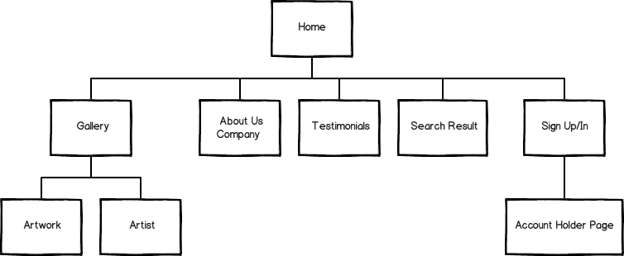

- Wireframe for Master Page
- Master Template Page
The master page will be the template for all pages made except for reports and the sign up page. Its content will be populated in the blank frame space. The chat window at the bottom of the page is seen by clicking on the tab at the bottom.
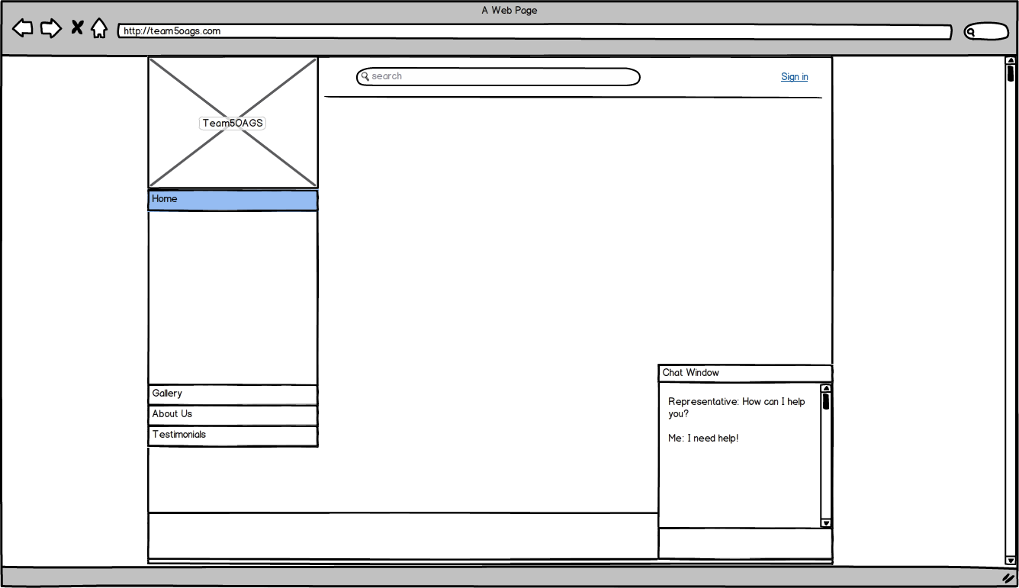

- Gallery Template
The Gallery page will be used to show thumbnails of artists and artwork being sold at TEAM5OAGS website. The top banner is the current sale or promotion being offered at TEAM5OAGS.
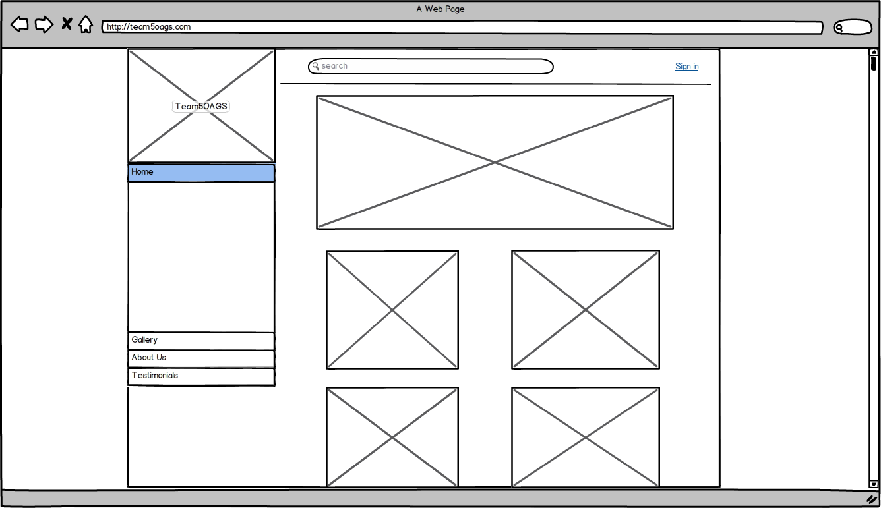

- Account Holder Template Page
The account holder template page is the page for account holders to see reports or orders. Each actor will have a different menu to the left.
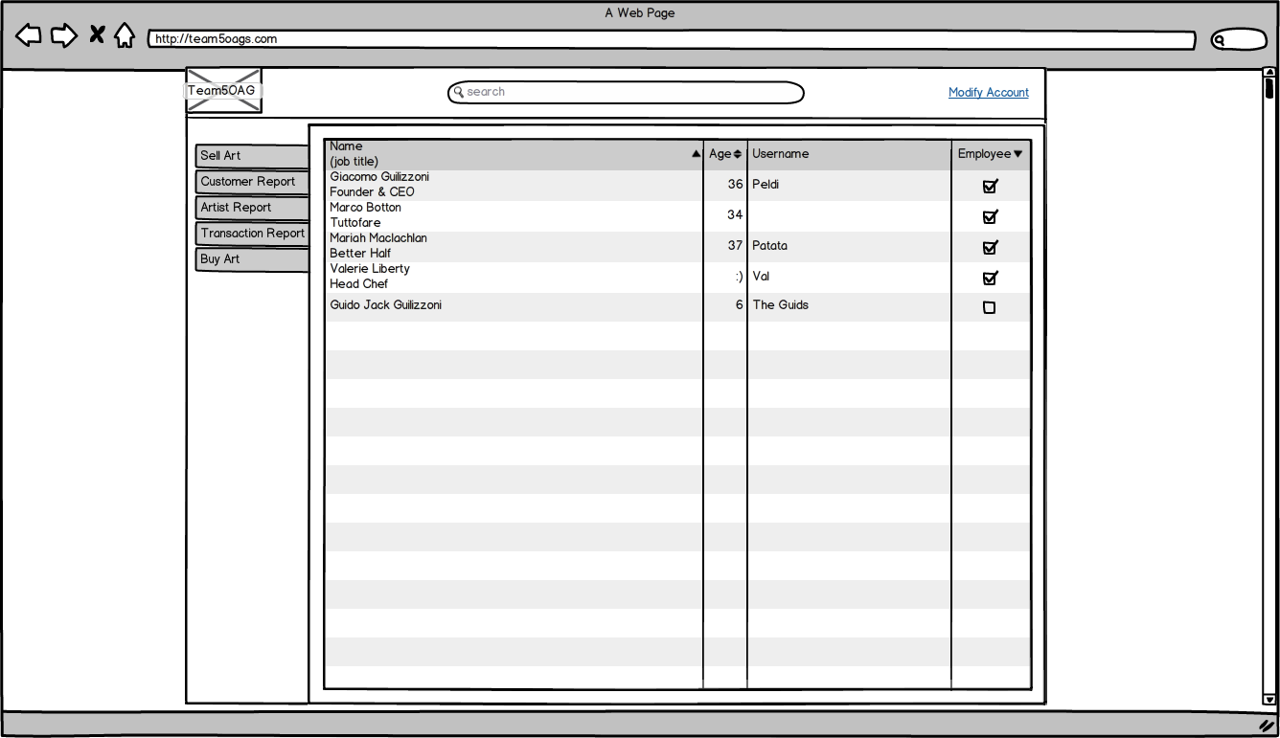

- Sign Up / Sign In Page
The sign up page template is for new guests to sign in or sign up.
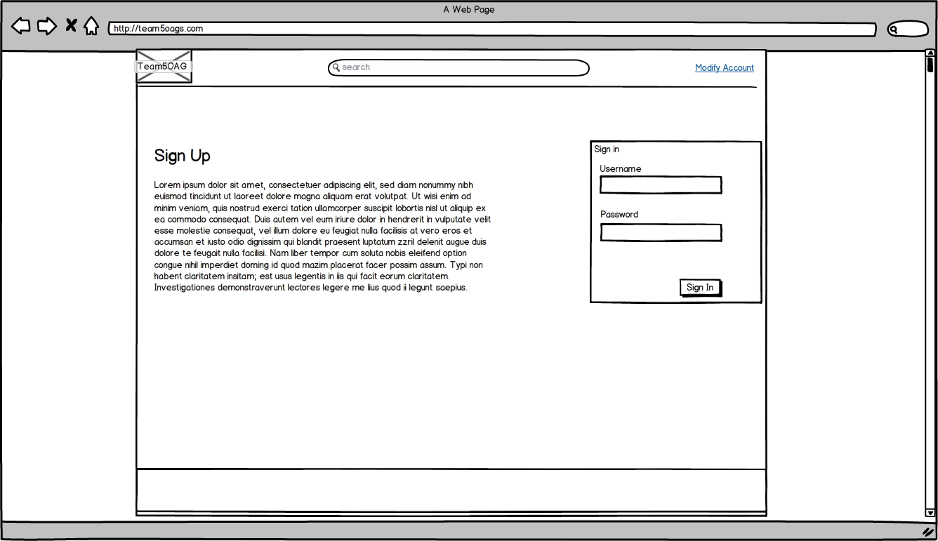

- About Us
About Us is the template page for providing guests with information about TEAM5OAGS and locational information.